

Please find the below details for the solution created for the given task.

**Host:**

Created 2 different hosts i.e. Host_A and Host_B. Please refer below snapshot for the same.

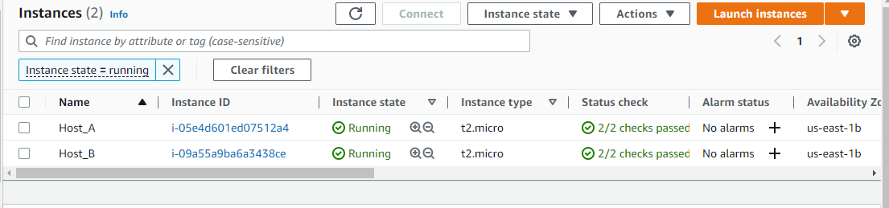

**VPC:**

Created one VPC in a private subnet, so it will not expose outside. Please refer below snapshot for the same.

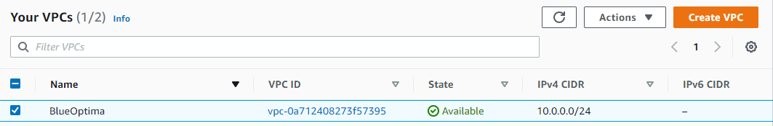

**Subnet:**

Created two subnets one is S1 and the other is S2. Please refer below snapshot for the same.

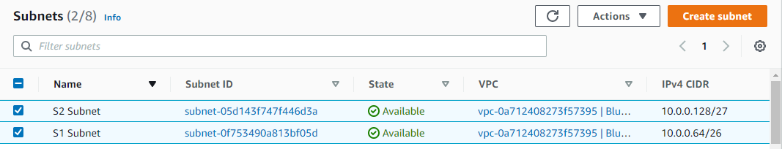

**NACL:**

I have added NACL for this assignment, we use NACL to filter the inbound and outbound traffic from the subnet level, where the security group work at the instance level.

So created inbound and outbound rules as per the below snapshot.

**Inbound Rule:**

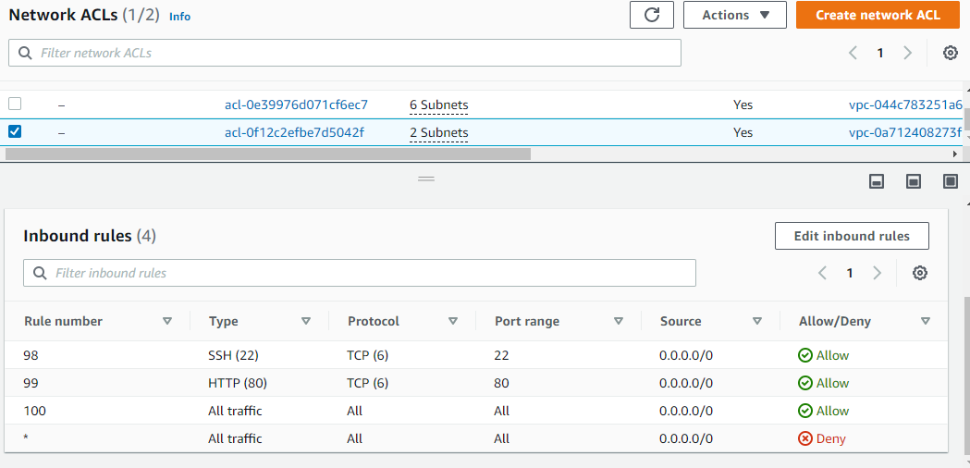

**Outbound Rule:** 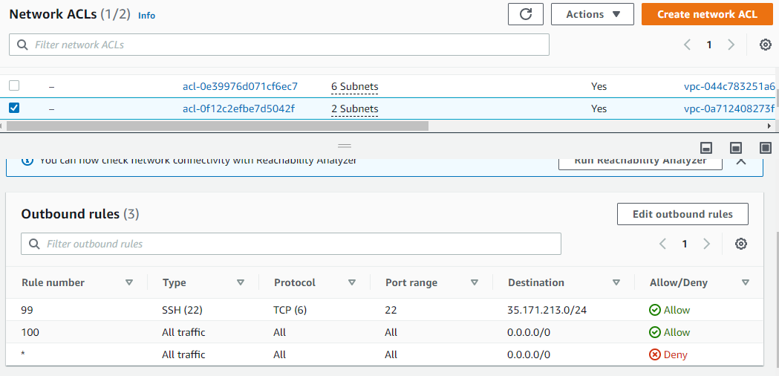

**Security Group:**

We use a security group to manage instance traffic and we can restrict access.

It plays a big role while connecting or accessing instances. Please find below rule created for an inbound and outbound rule.

**Inbound:**

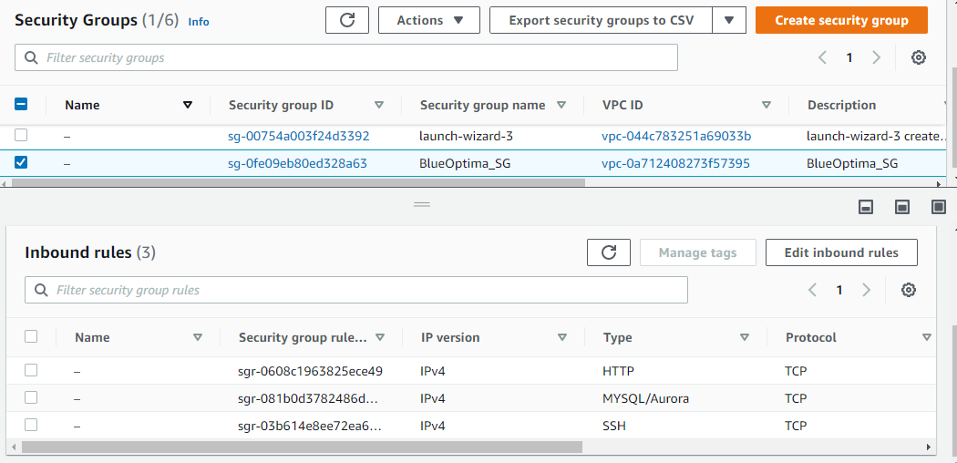

**Outbound:**

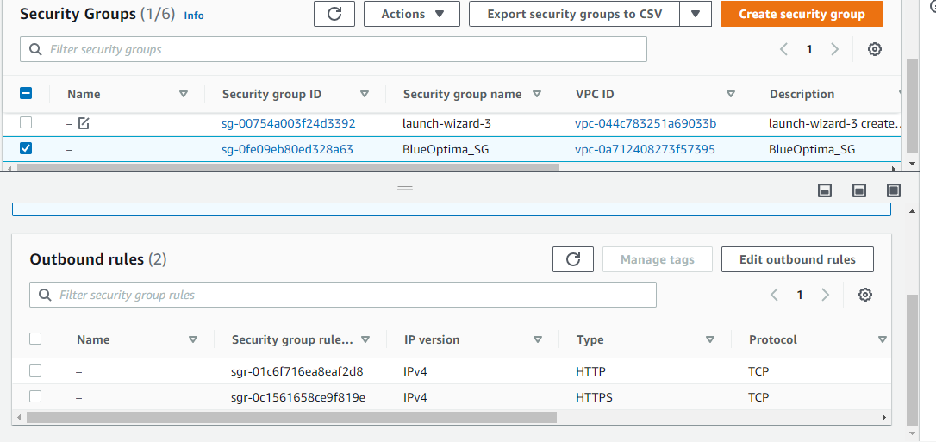

**NAT Gateway:**

Created a NAT Gateway for that outgoing access to the Internet via ports 80 and 443 only.

Also, it will help to not expose private networks and we easily can access the internet service.

